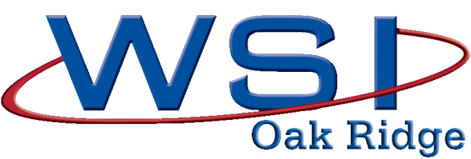
Job Title: Human Resources Intern

Summary
Human Resources Intern responsibilities: assisting the Human Resources department with a variety of processes and procedures, including but not limited to: updating and reviewing all job descriptions to ensure compliance; reviewing current policies and procedures, analyzing worker’s comp and short term disability claims, diversity awareness programs, and monthly reporting to upper management and the Department of Energy. This position will spend their time in each of the following HR departments: Employee Relations, Compensation and Benefits, Risk Management, and Labor Relations.

Responsibilities
- Review and update all job descriptions to ensure compliance with federal and state laws.
- Review HR Policies and Standard Practices for possible clarification and/or consolidation.
- Analyze work restrictions and days away from work for employees out on leave for worker’s comp and/or short term disability.
- Retrieve data from multiple sources for recording/reporting purposes.
- Assist with monthly metrics and reporting.
- Assist the labor relations division with filing.
- Provide support to the Diversity/Legal Specialist, Recruiting Specialist, HR Specialist, Labor Relations Specialist, Records Management Specialist, and Disability Specialist.

Education/Experience
Student currently pursuing a Bachelor’s degree in Human Resources or Business.

Knowledge, Skills, Abilities
- Knowledge, skills, and ability to perform general HR tasks.
- Knowledge of employment laws, concepts, practices, and procedures.
- Skilled in organizing, tracking, and prioritizing assignments and tasks.
- Knowledge of Human Resources responsibilities and functions.
- Skilled in effectively communicating with all applicants and co-workers
- Knowledge of MS PowerPoint, Word, and Excel.

Competencies
- Organization- Ability of the individual to be structured and methodical in working skills.
- Prioritization- how effective the person is at doing 'first things first;' as a process; it means evaluating a group of items and ranking them in their order of importance or urgency.
- Team oriented- Ability to help ensure that team members are invested in team activities and decisions, and that the team works together to achieve a goal.
- Oral and written communication skills
- Flexible- Ability to adjust duties and workflow due to changes in the work environment.
- Technical aptitude-experience with computer and software to communicate and produce documents

